Effects of Demographic Factors on Acceptance Rates Among Rushes of the Tau Chapter of Alpha Phi Omega at the University of Florida
Claire Layton
STA4211 – Design of Experiments, The University of Florida
ABSTRACT
The Tau chapter of Alpha Phi Omega at the University of Florida conducts recruitment, known as rush, each semester and seeks to accept diverse and qualified individuals in an unbiased manner. This project aims to identify potential biases in the fraternity’s rush process using data collected from questionnaires filled out by potential new members. A binary logistic regression model was fitted, and potential biases in recruitment were identified. The final reduced model identified semester rushed, previous connection with a fraternity Brother, self-identified personality, and year in college as significant factors in predicting whether a rush will be offered a bid. While these factors were statistically significant, some data was missing or incomplete in the data set which should be resolved in future studies to improve the model’s strength and accuracy.
INTRODUCTION
As the largest co-ed service fraternity in the nation, Alpha Phi Omega seeks to create an inclusive, service-oriented environment for its members in support of the fraternity’s three primary principles: leadership, friendship, and service. Tau chapter at the University of Florida holds recruitment twice a year, at the beginning of each spring and fall semester. The chapter seeks to accept a diverse group of service-oriented individuals each semester, who accurately reflect the student body, so the inclusivity of both advertising methods and the rush process is a concern of current chapter leaders. Tau chapter’s rush process is typically about two weeks in length and includes many varied events through which Brothers (full members of the fraternity, of any gender) are introduced to potential new members, called rushes. When rushes attend information meetings at the beginning of the rush process, they are asked to fill out a brief survey which includes a demographic and personality questionnaire. At the end of the rush process, rushes are either given a bid, which is a formal offer to become a pledge of the fraternity or denied a bid. For this observational study, information from each rush considered for a bid offer was collected, starting from fall 2016 and ending at spring 2020, for a total of eight consecutive semesters of collected data.
DATA
A total of 416 questionnaires and bid offer results were collected, which represented 400 individuals who participated in rush only once and 8 individuals who participated in rush twice, for a total of 408 unique individuals. Out of the 416 bid offer results, 294 were offered a bid, for an overall acceptance rate of 70.7%. Depending on the semester, questionnaires were administered at information meetings at the beginning of the rush process as either a paper document or a Google form that rushes filled out using their phones. The questions asked to receive the responses examined in this study did not vary from semester to semester. The variables collected from the questionnaires were matched with fraternity records of that rush’s acceptance or denial of a bid. The categorical variables collected were semester rushed, year in college, gender, address location, previous acquaintance with a fraternity brother, recruitment source, previous scouting experience, and self-described personality. For each variable, graphs were produced for visualizing frequency of responses and the proportion of each response rate that was extended a bid (binary response variable). Individual responses with names redacted can be found in the attached file, APO_Project_Dataset.csv.
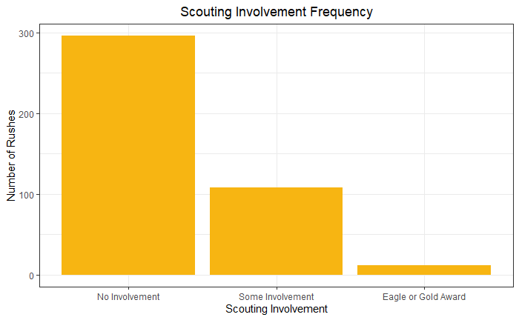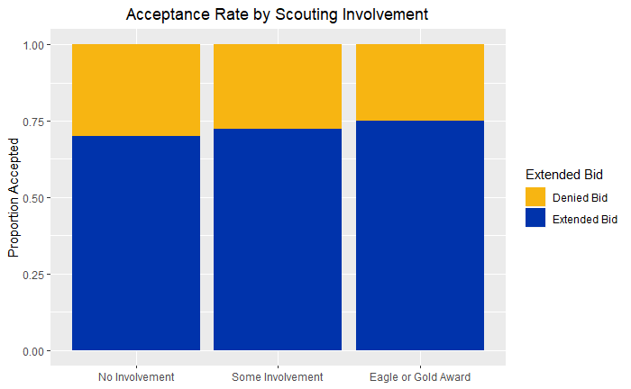
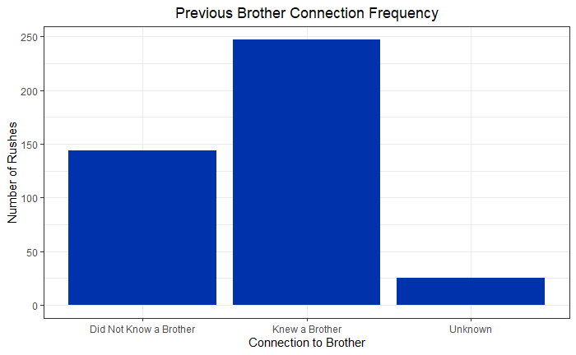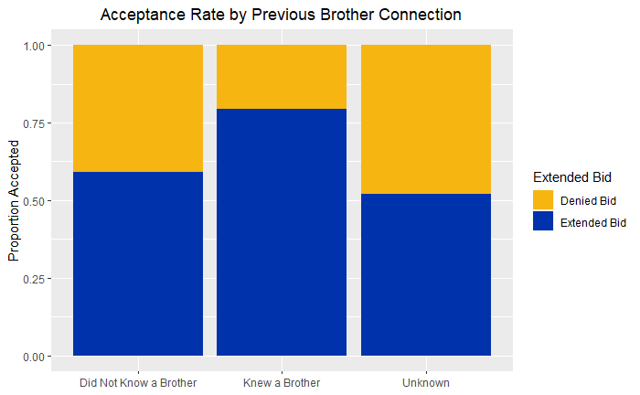
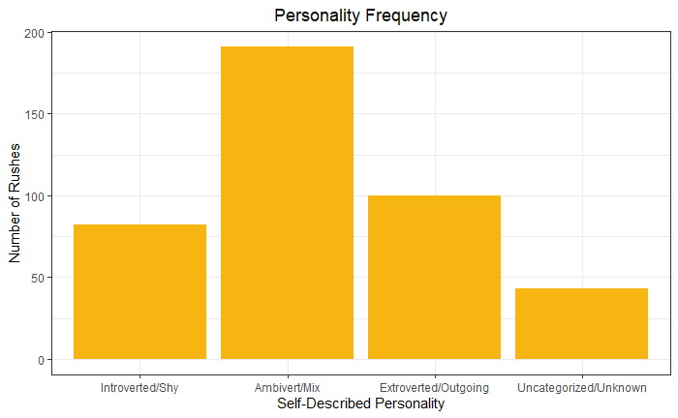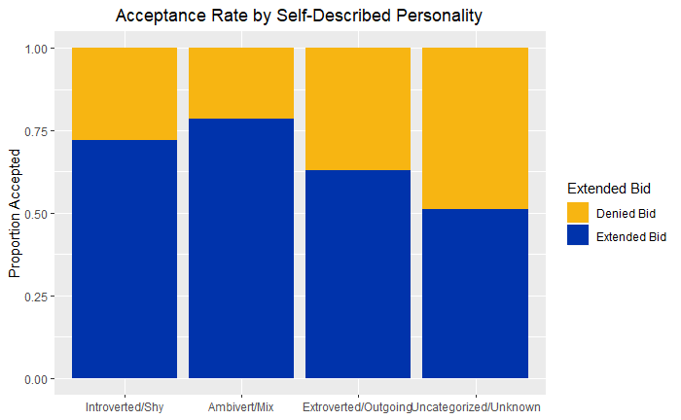
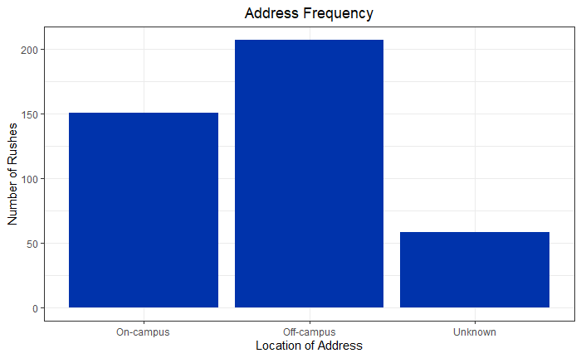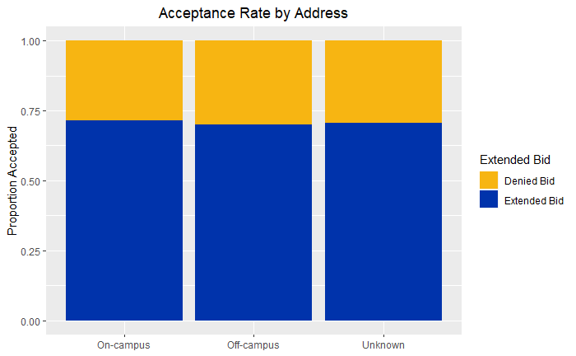
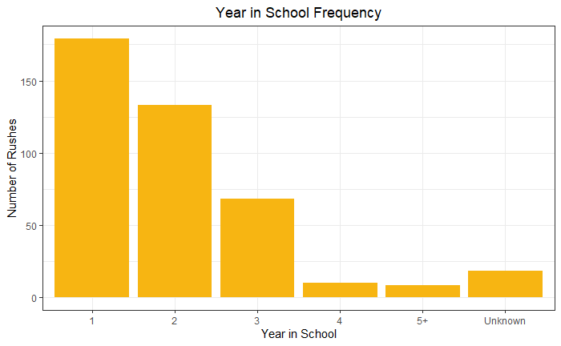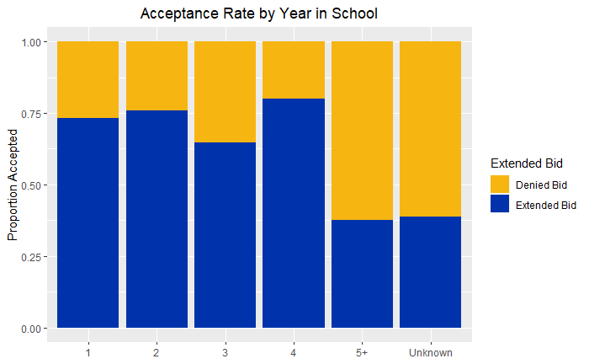

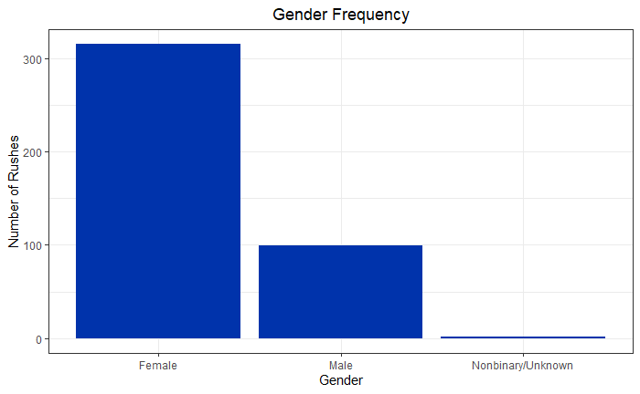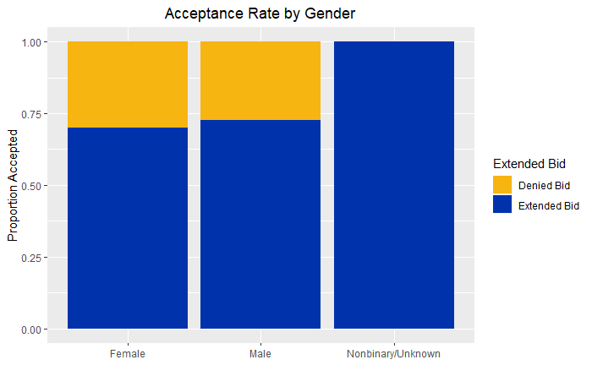
Note the small sample size for the Nonbinary/Unknown group (n = 5).
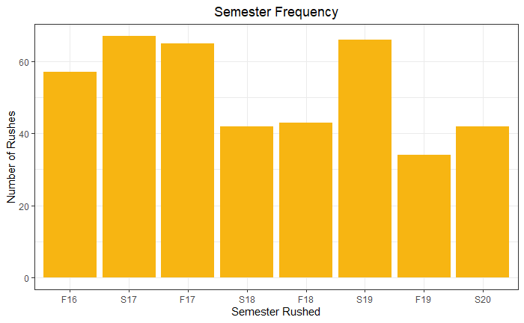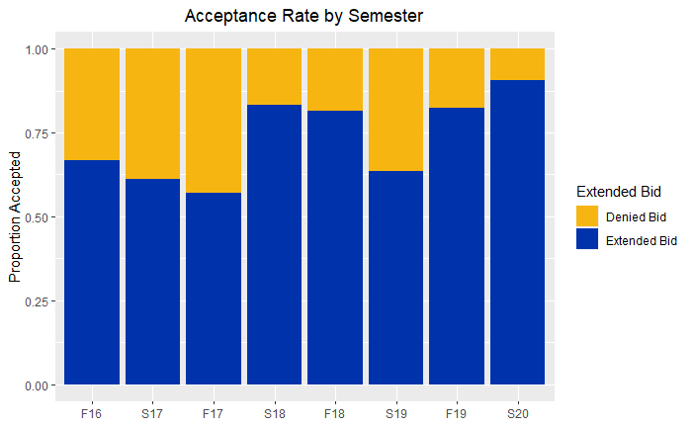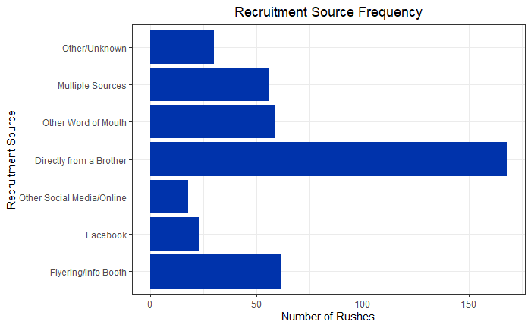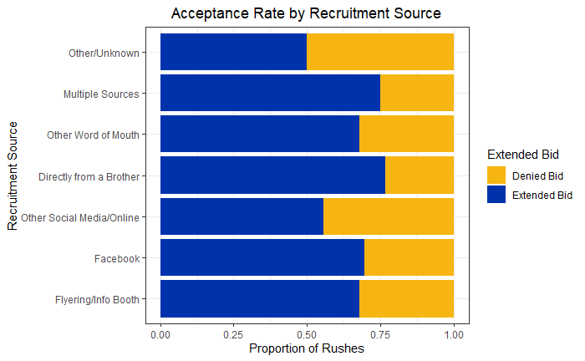

Additional graphs were made for future fraternity leaders to interpret for the planning of advertising for future semesters of recruitment, as the most successful recruitment sources are of financial interest to the fraternity. As the fraternity lacks an even gender divide, dividing recruitment source responses by gender was also of interest.
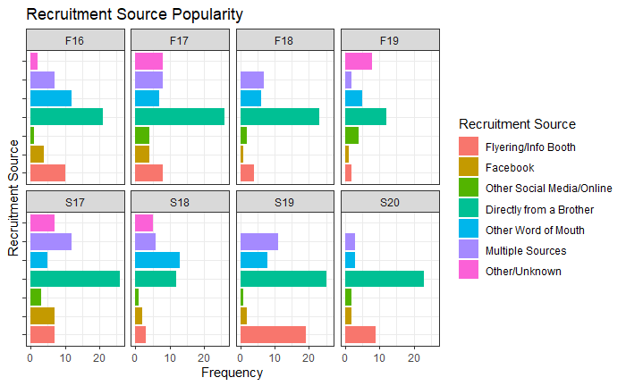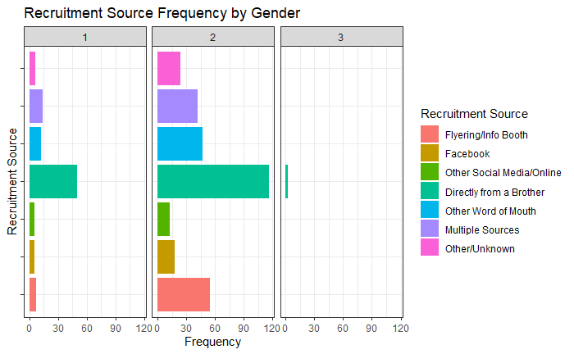
1 = Male, 2 = Female, and 3 = Nonbinary/Unknown
METHODOLOGY
Due to the usage of a binary response variable, a binary logistic regression model was utilized. Additionally, due to missing data, each of the categorical variables included a category which was for uncategorizable or missing data. Missing data in most cases was caused by individual questions on the questionnaire left blank, while in other cases was caused by either lack of proper recordkeeping or a failure to administer the questionnaire to rushes that may have been unable to attend a rush information meeting.
For some predictor variables, additional categories were created or combined for unexpected responses. For year in college, a category was designated for students who reported they were either in their fifth year of undergrad or in graduate school, while a separate category represented students whose year in college was unknown. For recruitment source, two additional categories were created: one for missing or uncategorizable responses and one for responses that indicated multiple recruitment sources. Due to ambiguity in the wording of the question which asked rushes to report their scouting experience, nonresponses and reports of no scouting experience were grouped together into a single category.

MODEL FITTING
The binary logistic regression model used was where α represents the intercept and x_{i} represents each factor level from the data set included in the model and (i = 1, 2, … 29). This type of model was initially fit on all eight predictor variables.
logisticFullModel = glm(Accepted ~ Semester + Address + Gender + KnewBrother + Personality + RecruitmentSource + Scouting + Year, family = binomial(link = "logit"))
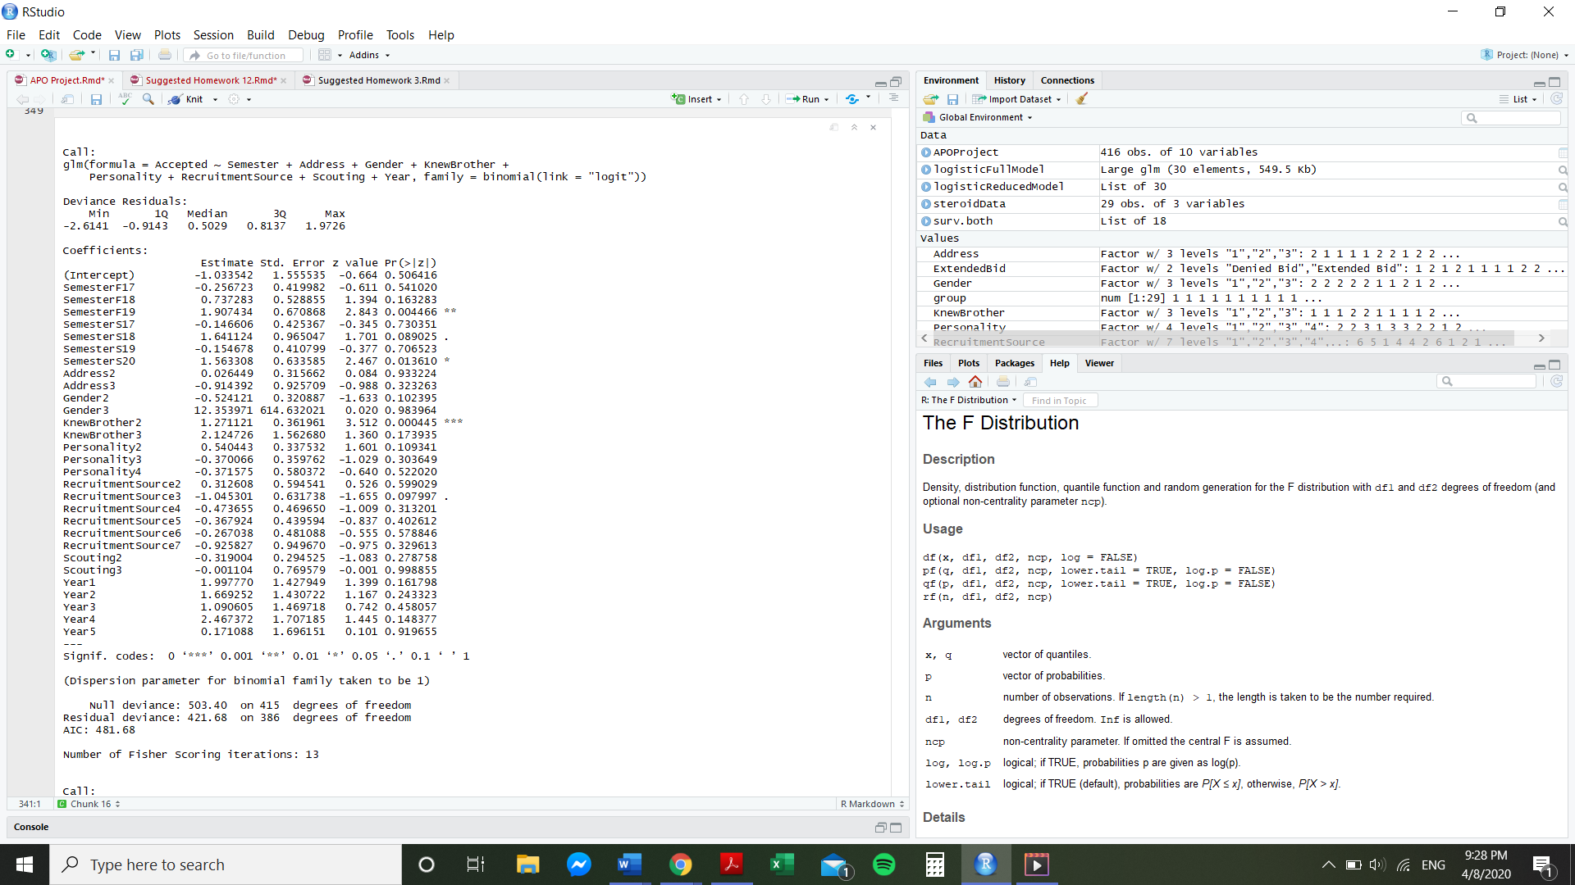
AIC Backward Elimination was used to identify significant predictor variables to retain in the reduced model. Additionally, p-value backward elimination with α = 0.10 was used to confirm the AIC Backward Eliminations results. Both techniques reached the same conclusion, and the predictor variables of address location, gender, scouting experience, and recruitment source were removed for the reduced model since none of their levels presented a difference significant at the α = 0.10 level. The following reduced model was accepted.
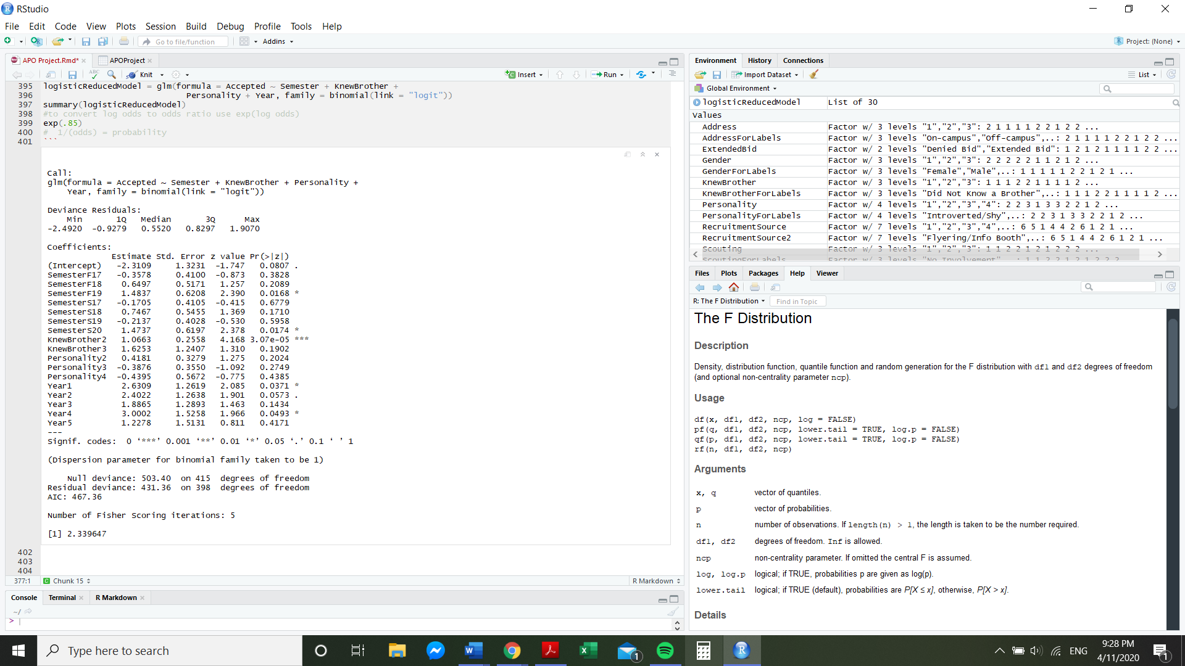

The base group in this model was a rush from fall 2016, who did not have a connection with a fraternity Brother prior to rushing, had an introverted personality, and was of an unknown year in college. Individuals in the base group had a log odds of -2.31, which corresponds to a probability of acceptance of 0.09. The remaining estimates can be interpreted for each individual by calculating the predicted chance of receiving a bid given their factors. The probability of a rush being offered a bid according to the reduced model can be calculated using the following formula:
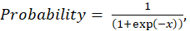 where x =
Where each x_{i} = 1 if that feature applies to the individual, and x_{i} = 0 if that feature does not apply, and x1 = rushing in fall 2017, x₂ = rushing in fall 2018, x₃ = rushing in fall 2019, x₄ = rushing in spring 2017, x₅ = rushing in spring 2018, x₆ = rushing in spring 2019, x₇ = rushing in spring 2020, x₈ = having a prior connection with a fraternity Brother, x₉ = having unknown connection to a fraternity Brother, x₁₀ = having an ambivert or mixed personality, x₁₁ = having an extroverted or outgoing personality, x₁₂ = having an unknown personality, x₁₃ = being a first year undergraduate, x₁₄ = being a second year undergraduate, x₁₅ = being a third year undergraduate, x₁₆ = being a fourth year undergraduate, x₁₇ = being a fifth year undergraduate or graduate student.
Therefore, according to this model, an individual with the characteristics of the base group has a probability of receiving a bid of
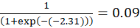.
The combination of characteristics most probable to be offered a bid according to this model is an individual who rushed fall 2019, had an ambivert or mixed personality, had unknown connections to fraternity Brothers prior to rushing, and was a fourth year undergraduate. This individual had a predicted probability of receiving a bid equal to
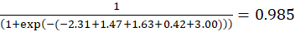.
The combination of characteristics least probable to be offered a bid according to this model is an individual who rushed fall 2017, had no connection to a fraternity Brother prior to rushing, had an unknown personality, and were of an unknown year in college. This individual had a predicted probability of receiving a bid equal to
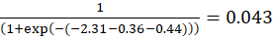.
MODEL ASSUMPTIONS
In a binary logistic regression model, multiple assumptions must be met. Firstly, the response variable must be binary. This it assumed to be true, as rushes could not be both accepted and denied a bid, so the outcome must be binary.
Next the logistic regression model assumes that observations are independent from one another. As each individual filled out their own survey without assistance, we can assume that the observations are independent from one another. Although eight subjects were included twice in the study because they participated in rush twice, some of their recorded variables changed. For all eight of the individuals, their semester rushed changed between taking the first and second questionnaire. Additionally, for some of them, their responses for year in college, address location, previous acquaintance with a fraternity brother, recruitment source, and self-described personality also changed. Thus, since the majority of the measured variables were able to change between measurements and since these subjects represented a vast minority of the sample size (8 out of 408), the assumption of independence of observations can be assumed.
The next assumption that must be verified is that there must exist a linear relationship between the logit of the outcome and each predictor variable. Since each predictor variable is categorical, we can assume that this assumption is met.
The last assumption that must be checked is multicollinearity between the predictor variables. This assumption was checked by calculating the variation inflation factors of all predictors in the full model, using the vif() function in R.
vif(logisticFullModel)
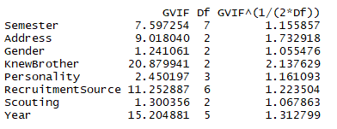
As all VIF values were all below 5, we can assume that there is not a problematic amount of collinearity for any of the predictor variables in the full model. Thus, we can proceed with using a binary logistic regression model for this study.

CONCLUSIONS
From this study, it was found that the most significant factors in predicting if a rush will receive a bid are semester rushed, prior connections with fraternity Brothers, self-described personality, and year in college. Knowing a Brother before rushing increased the probability that rushes would be offered a bid. Having an ambiverted or mixed personality also increased the probability that rushes would be offered a bid. Rushes in their first four years of undergraduate study appeared to have an advantage over rushes who were fifth year undergraduates, graduate students, or were in an unknown year of study.
For all factors in the final model except prior connection with Brothers, missing or uncategorized data led to a decrease in the probability a rush would be offered a bid. This should emphasize the importance of gathering equal information on all rushes to ensure a fair selection process. Missing information could falsely indicate that rushes were uninterested in joining the fraternity, when missing data was more likely to occur due to failure to administer the questionnaire or failure to correctly document the questionnaire in fraternity records.
Prior to this study, admission biases were expected to occur, such as favoring younger rushes in order to maximize fraternity investments and improve retention rates or favoring rushes with scouting involvement due to scouting demonstrating a previous involvement with service-related activities. While these factors did not appear to be statistically significant in this observational study, other more discriminatory biases should be addressed to improve the rush process. The apparent bias in acceptance rates due to semester rushed is unavoidable since it is dependent upon the number of bids available and the turnout at rush events, however the other significant factors (prior connection to fraternity Brothers, personality, and year in college) reflect possible biases in the admission process that stand to be amended through conscious effort by fraternity leaders and redesigning of the rush process.
As an observational study, the results of the model do not imply causation, especially since other factors exist which could have impacts on acceptance rates, such as the number and types of events attended by rushes during the rush period. The results of this project could be used to motivate further efforts towards improving rush and the bid selection process, especially focusing on removing biases due to prior connection to fraternity Brothers, personality, and year in college.
In the future, fraternity leaders in charge of rush should aim to digitize questionnaires and have rushes fill them out as thoroughly as possible. Digitizing the questionnaire will greatly reduce the labor required to synthesize future datasets. Certain questions in the questionnaire could also be reworded or made to be multiple choice instead of free response to make categorization simpler and clearer. For instance, if the data set had been complete and graduate students and fifth year undergraduates could be differentiated from each other, year in college could have been treated as a continuous variable, thus reducing the number of dummy variables needed in the initial model. Future studies should also consider additional factors of interest such as the number of rush events attended. It is possible that there are interaction effects between certain factors in this study and the number of events attended, so future studies should consider interaction terms between factors.

